Configuring Your Federation
I’m here to explain WCF claims in federated services using STS (security token service) from a layman’s perspective. I’ve started with the set of configuration you have to put in place on web.config under system.serviceModel to make your service in a federated way. Instead of a very boring textual explanation, I’m explaining it in a comic way.
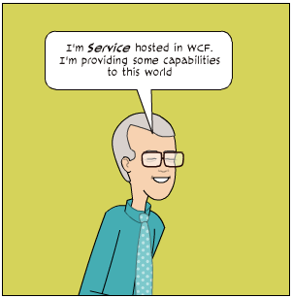
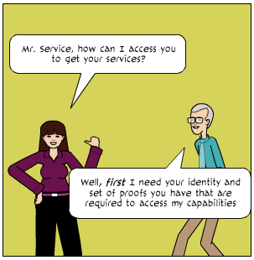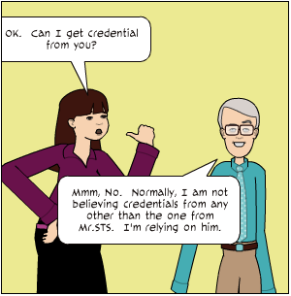
This is to be declared inside <binding> -> <security> element of system.serviceModel section of web.config.
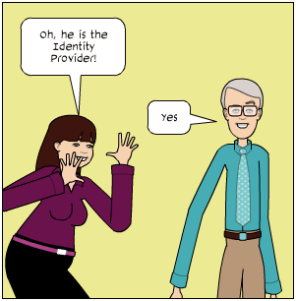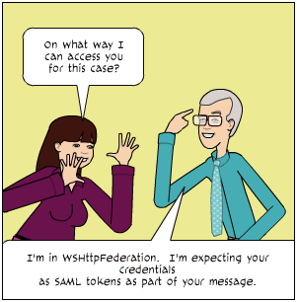
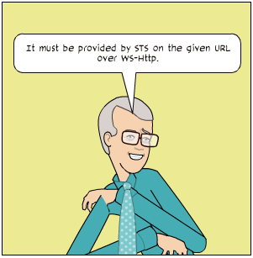
<wsFederationHttpBinding>
<binding name="wsFed">
<security mode="Message">
<message issuedTokenType=
"<strong>http://docs.oasis-open.org/wss/oasis-wss-saml-token-profile-1.1#SAMLV1.1
</strong>" negotiateServiceCredential="false">
<issuer address="<strong>http://udoozSTS/TokenService.svc</strong>"
binding ="wsHttpBinding" bindingConfiguration="udoozSTSBinding" >

</issuer>
</message>
</security>
</binding>
</wsFederationHttpBinding>
The <issuer> is the place you have to tell where STS is hosted over which binding with appropriate binding configuration. This service expects SAML 1.1 provided by udoozSTS. Since this is expected as part of the request message, it has been declared in Message security mode.
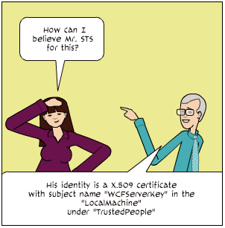
This is has to be declared in <identity> section of <issuer>.
<identity>
<certificateReference
findValue="WCFServerKey"
x509FindType="FindBySubjectName"
storeLocation="LocalMachine"
storeName="TrustedPeople" />
</identity>
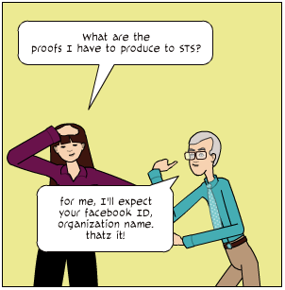
This has to be declared in <claimTypeRequirements> element under <message>.
<claimTypeRequirements>
<add claimType="http://schemas.udooz.net/2010/12/identity/claims/facebookId"
isOptional="false"/>
<add claimType="http://schemas.udooz.net/2010/12/identity/claims/orgName"
isOptional="false"/>
</claimTypeRequirements>
The whole configuration related to this is:
<bindings>
<wsFederationHttpBinding>
<binding name="mrservice">
<security mode="Message">
<message issuedTokenType=
http://docs.oasis-open.org/wss/oasis-wss-saml-token-profile-1.1#SAMLV1.1
negotiateServiceCredential="false">
<claimTypeRequirements>
<add claimType="http://schemas.udooz.net/2010/12/identity/claims/facebookId"
isOptional="false"/>
<add claimType="http://schemas.udooz.net/2010/12/identity/claims/orgName"
isOptional="false"/>
</claimTypeRequirements>
<issuer address="http://udoozSTS/TokenService.svc"
binding ="wsHttpBinding" bindingConfiguration="udoozSTSBinding" >
<identity>
<certificateReference
findValue="WCFServerKey"
x509FindType="FindBySubjectName"
storeLocation="LocalMachine"
storeName="TrustedPeople" />
</identity>
</issuer>
</message>
</security>
</binding>
</wsFederationHttpBinding>
<bindings>
The proofs are called as claims. A collection of claims about a consumer provided by an identity provider (STS) with its identity is called as ClaimSet.
In the previous post, we have seen the service configuration of WCF federation. In this post, let us see the STS configuration.
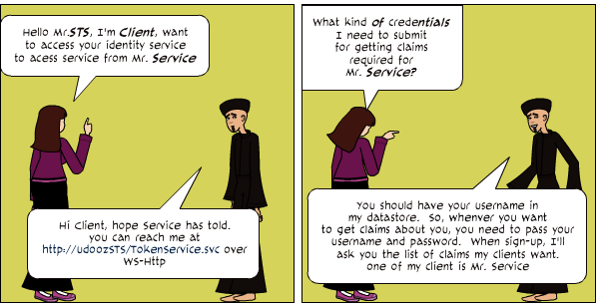
In the STS’s configuration file, it is mentioned in <message> element.
Collapse
<system.serviceModel>
<services>
<service name="Udooz.SecurityTokenService" behaviorConfiguration="stsBehavior">
<endpoint contract="Udooz.ISecurityTokenService"
binding="wsHttpBinding" bindingConfiguration="stsBinding"/>
</service>
</services>

<bindings>
<wsHttpBinding>
<binding name="stsBinding">
<security mode="Message">
<message clientCredentialType="UserName" />
</security>
</binding>
</wsHttpBinding>
</bindings>
The STS service contract is declared in Udooz.ISecurityTokenService and implementation is resided in Udooz.SecurityTokenService.
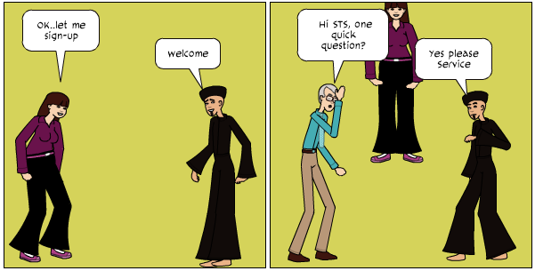
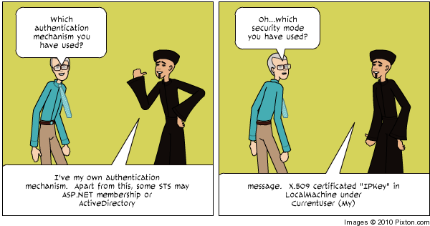
The message security mode is specified in <binding>..<wsHttpBinding>..<binding name=”stsBinding”>…<security>.
This is specified in the <serviceBehaviors> section named “stsBehavior”.
Collapse
<behaviors>
<serviceBehaviors>
<behavior name="stsBehavior">
<serviceCredentials>
<userNameAuthentication
userNamePasswordValidationMode="Custom"
customUserNamePasswordValidatorType=
"UdoozCommonLib.STSUsernamePasswordValidator, UdoozCommonLib"/>
<serviceCertificate findValue="WCFServerKey"
x509FindType="FindBySubjectName"
storeLocation="LocalMachine" storeName="My" />
</serviceCredentials>
</behavior>
</serviceBehaviors>
</behaviors
The username-password authentication is done by UdoozCommonLib.STSUsernamePasswordValidator class in UdoozCommonLib assembly.

